# CS 255 System Design Document Template

This template lays out all the different sections that you need to complete for Project Two. Each section has guidance to prompt your thinking. You will need to continually reference the interview transcript as you work to make sure that you are addressing your client’s needs. There is no required length for the final document. Instead the goal is to complete each section based on what your client’s needs are. Remove this note when you are finished, and replace all bracketed text with the relevant information.

## UML Diagrams

UML Use Case Diagram

*.]*

UML Activity Diagrams

*[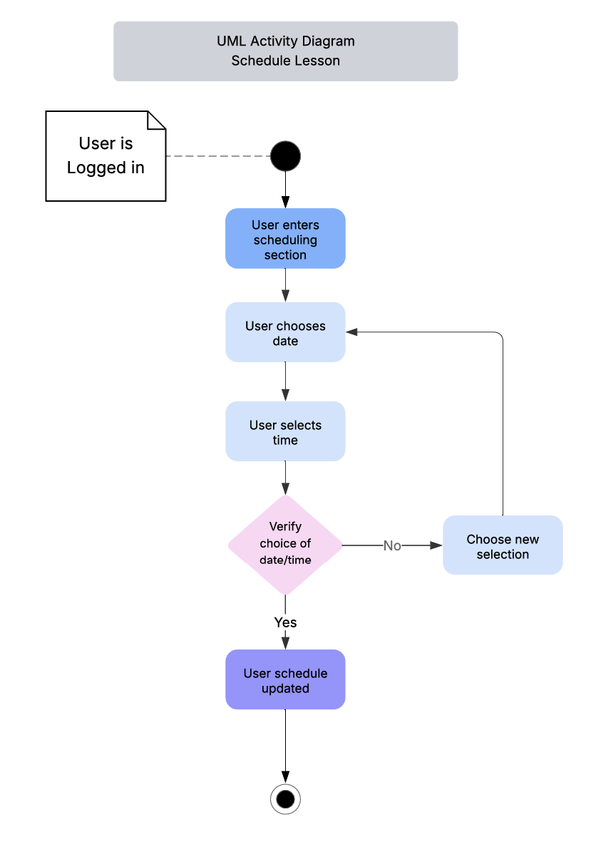*

### UML Sequence Diagram

### UML Class Diagram

*]*

## Technical Requirements

*[The technical requirements for this system start with the hardware.  A server will need to be housed at the DriverPass main office.  This will be the server for the clients to link into.  The secretary will also need a desktops computer to set up user profiles and schedule appointments when the customer calls in. She will also need a monitor, keyboard, and mouse.  The main office will also need internet.  As this is an online program, another requirement will be Windows Software for the program to run on.  They will want security software as they are storing customer’s confidential information such as credit card numbers.  The client will also need a desktop or mobile device to be able to interact with DriverPass. They will need to be able to access the internet and have a web browser as well. Another requirement would be that the system responses within 3 seconds. For security requirements each user will have their own unique username and password, passwords will need to be changed every 90 days.]*

**Citations**

CS 255 Project Two Guidelines and Rubric

<https://learn.snhu.edu/d2l/le/content/1860210/viewContent/39474880/View>